LGBT+ History Month UK 2021 - Quiz | 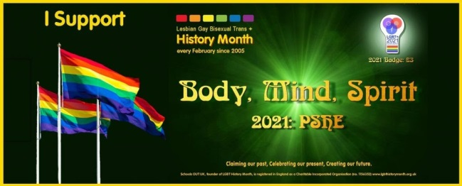

Section 1: LGBT Faces of 2021
- Hailed by the press as the “the most brilliant female (football) player in the world”, Lily Parr scored __ __ __ goals throughout her career.

- Lily Parr is the first British female footballer commemorated with a statue unveiled in June 2019 at the _____ _____ _____ in Manchester.

- Four months into the year- long UK Miner’s Strike, Mark Ashton formed _____ & _____ _____ the _____ with Mike Jackson by initially organising a bucket collection at the June 1984 London Pride march.

- Which song did Jimmy Somerville (Bronski Beat and The Communards) write in 1987 memory of his friend Mark Asthon, which also was featured in the film ‘Pride’?

- On top of being a renowned author, poet and civil rights activist, TIME Magazine pointed out a number of Maya Angelou’s jobs in her 2014 obituary. Name two

- Maya Angelou’s 1969 debut memoir ____ _____ _____ _____ _____ _____ _____ brought identity, racism and sexual assault into the national conversation.

- (Laurence) Michael Dillon is known for being a British physician and the first trans man to undergo _____ in the UK

- After being outed on national media, Michael Dillon headed to India and became a _________ ___________

- Mark Weston (born Mary Louise Edith Weston) was the first intersex British field athlete to change gender publicly, with articles and interviews published in 1936 in both the UK and the US. What was Mark’s athletic nickname?

- Mark Weston was a national champion in three women’s throw categories __________, ____________ and ____________

Section 2: LGBT History Theme: Body, Mind, Spirit
Body:
1. A 2016 BBC Radio 5 Live survey found that __ % of football supporters would have no issue with their club signing a gay player?
a) 98%
b) 82%
c) 56%
2. In 2017, which country banned the Warwick Rowers Naked Charity Calendar?
3. Who won the Sports Personality Award in the 2020 British LGBT Awards?

Mind:
4. Which London University did Freddie Mercury graduate from?
a) Central St Martins
b) Ealing Art College
c) Royal College of Art

5. Who was the real life WWII hero that the film ‘The Imitation Game’ featuring Benedict Cumberbatch was based on?
6. What is Sally Ride best known for?

Spirit:
Explore the following symbols and the communities/identities they represent
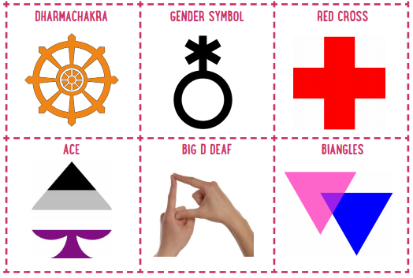

Section 3: LGBT+ History
- In which South American country does the village of Nazareth offer refuge and support for indigenous gay men?
- Venezuela
- Chile
- Colombia
- Schools OUT UK - The LGBT+ Education Charity, the founding organiser of LGBT+ History Month UK, was formed in ____ following the sacking of a London teacher who had been 'outed' to his managers by a student.
- 1970
- 1974
- 1978

- Pete Buttigieg made history this week when voted as the first openly gay US Senate cabinet member, serving as Secretary of:
- Defense
- Housing and Urban Development
- Transportation

- In December 2020, which South Asia country published its first workplace equality index report, a benchmark tool to measure progress on LGBT+ inclusion in the workplace?
- India
- Sri Lanka
- Maldives

- Who of the following members of the US Supreme Court that voted to make same-sex/equal marriage legal in the United States in 2015?
a) Stephen Anthony Sotomayer
b) Elena Day O’Connor
c) Ruth Bader Ginsberg

- What is the name of the Channel 4 drama which was based around Manchester’s Canal Street area?

- In April 1988, Capital Gay (a former weekly free gay newspaper published in London) reported about the ‘Fleet Street Four’. What were they arrested for?

- Which popular American singer set up the charity ‘The Happy Hippy Foundation” in 2015 to benefit LGBT+ homeless and at-risk youth?

- Hephaestion was the male lover of which famous ancient King and conqueror?

- World renowned performer, the first Black woman to star in a major motion picture, World War II spy, and civil rights activist are few of the titles used to describe _________ _________

Thank you and well done
Happy LGBT+ History Month UK 2021

Quiz Created by Andrew Francalanza
Twitter: @A_Francalanza
LinkedIn: linkedin.com/in/andrewfrancalanza

