LGBT+ History Month UK 2021 –  Quiz Answers | 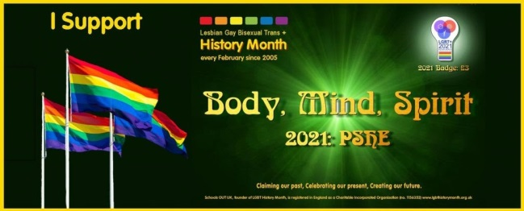

Section 1: LGBT Faces of 2021
- Hailed by the press as the “the most brilliant female (football) player in the world”, Lily Parr scored 980 goals throughout her career.

- Lily Parr is the first British female footballer commemorated with a statue unveiled in June 2019 at the National Football Museum in Manchester.

- Four months into the year- long UK Miner’s Strike, Mark Ashton formed Lesbians & Gays Support the Miners (LGSM) with Mike Jackson by initially organising a bucket collection at the June 1984 London Pride march.

- Which song did Jimmy Somerville (Bronski Beat and The Communards) write in in 1987 memory of his friend Mark Asthon, which also was featured in the film ‘Pride’? For a friend

- On top of being a renowned author, poet and civil rights activist, TIME Magazine pointed out a number of Maya Angelou’s jobs in her 2014 obituary. Name two.
Cook, waitress, sex-worker, dancer, actor, playwright, editor at an English language newspaper in Egypt, Calypso singer, cast member of the opera Porgy and Bess, and San Francisco’s first female African-American cable car conductor

- Maya Angelou’s 1969 debut memoir I know why the caged bird sings brought identity, racism and sexual assault into the national conversation. (the first non-fiction bestseller by an African-American woman)

- (Laurence) Michael Dillon is known for being a British physician and the first trans man to undergo phalloplasty.in the UK (construction or reconstruction of a penis)

- After being outed on national media, Michael Dillon headed to India and became a Buddhist Monk (the first Western European to be ordained)

- Mark Weston (born Mary Louise Edith Weston) was the first intersex British field athlete to change gender publicly, with articles and interviews published in 1936 in both the UK and the US. What was Mark’s athletic nickname? Devonshire Wonder

- Mark Weston was a national champion in three women’s throw categories; javelin throw, discus throw, and shot put throw.

Section 2: LGBT History Theme
Body:
1. A 2016 BBC Radio 5 Live survey found that __ % of football supporters would have no issue with their club signing a gay player? B) 82%
2. In 2017, which country banned Warwick Rowers Naked Charity Calendar? Russia
3. Who won the Sports Personality Award in the 2020 British LGBT Awards? Gareth Thomas

Mind:
4. Which London University did Freddie Mercury graduate from? B) Ealing Art College
5. Who was the real life WWII hero that the film ‘The Imitation Game’ featuring Benedict Cumberbatch was based on? Alan Turing
6. What is Sally Ride best known for? America's first woman in space, youngest astronaut in space, the first acknowledged lesbian/LGBTQ+ astronaut, and founder of the Sally Ride Science with a passion to interest young people, especially girls, in Science, Math and Technology

Spirit:
Explore various symbols and the communities/identities they represent
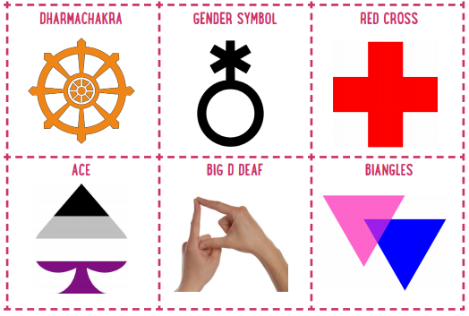
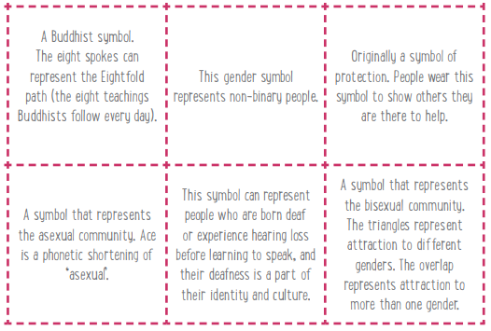

Section 3: LGBT+ History
- In which South American country does the village of Nazareth offer refuge and support for indigenous gay men? C) Colombia

- Schools OUT UK - The LGBT+ Education Charity, the founding organiser of LGBT+ History Month UK, was formed in ____ following the sacking of a London teacher who had been 'outed' to his managers by a student. B) 1974

- Pete Buttigieg made history this week when voted as the first openly gay US Senate cabinet member, serving as Secretary of: B) Transportation

- In December 2020, which South Asia country published its first workplace equality index report, a benchmark tool to measure progress on LGBT+ inclusion in the workplace? A) India

- Who of the following is a member of the US Supreme Court that voted to make same-sex marriage legal in the United States in 2015? C) Ruth Bader Ginsberg

- What is the name of the Channel 4 drama which was based around Manchester’s Canal Street area? Queer As Folk

- In April 1988, Capital Gay (a former weekly free gay newspaper published in London) reported about the ‘Fleet Street Four’. What were they arrested for?
Daubing Fleet Street with pink triangle to protest Section 28 becoming law.

- Which popular singer set up the charity ‘The Happy Hippy Foundation” in 2015 to benefit LGBT homeless and at-risk youth? Miley Cyrus

- Hephaestion was the male lover of which famous ancient King and conqueror? Alexander the Great

- World renowned performer, the first Black woman to star in a major motion picture, World War II spy, and civil rights activist are few of the titles used to describe Josephine Baker

Thank you and well done
Happy LGBT+ History Month UK 2021

Quiz Created by Andrew Francalanza
Twitter: @A_Francalanza
LinkedIn: linkedin.com/in/andrewfrancalanza

